**Project Planning Phase**

**Project Planning Template (Product Backlog, Sprint Planning, Stories, Story points)**

|  |  |
| --- | --- |
| Date | 30-06-2025 |
| Team ID | LTVIP2025TMID43096 |
| Project Name | Flight Finder: Navigating Your Air Travel Options |
| Maximum Marks | 5 Marks |

**Product Backlog, Sprint Schedule, and Estimation (4 Marks)**

Use the below template to create product backlog and sprint schedule

| **Sprint** | **Functional Requirement (Epic)** | **User Story Number** | **User Story / Task** | **Story Points** | **Priority** | **Team Members** |
| --- | --- | --- | --- | --- | --- | --- |
| Sprint-1 | Authentication & Setup | USN-1 | USN-1: Register as customer, admin, operator | 3 | High | Lakshmi |
|  |  | USN-2 | USN-2: Login logic with role check | 3 | High | Raju |
|  |  | USN-3 | USN-3: Setup MongoDB & backend | 2 | High | Sameer |
| Sprint 2 | Flight Management | USN-4 | USN-4: Add flight (flight operator) | 3 | High | Afrid |
|  |  | USN-5 | USN-5: View and filter flights (search) | 2 | High | Afrid |
| Sprint 3 | Booking System | USN-6 | USN-6: Book flight & input passenger data | 3 | Medium | Raju |
|  |  | USN-7 | USN-7: Cancel booking | 2 | Medium | Raju |
| Sprint 4 | Admin Management | USN-8 | USN-8: Approve/reject operator registration | 2 | Medium | Sameer |

**Project Tracker, Velocity & Burndown Chart: (4 Marks)**

| **Sprint** | **Total Story Points** | **Duration** | **Sprint Start Date** | **Sprint End Date (Planned)** | **Story Points Completed (as on Planned End Date)** | **Sprint Release Date (Actual)** |
| --- | --- | --- | --- | --- | --- | --- |
| Sprint-1 | 20 | 6 Days | 01 July 2025 | 06 July 2025 | 20 | 06 July 2025 |
| Sprint-2 | 20 | 6 Days | 08 July 2025 | 13 July 2025 | 18 | 13 July 2025 |
| Sprint-3 | 20 | 6 Days | 15 July 2025 | 20 July 2025 | 17 | 21 July 2025 |
| Sprint-4 | 20 | 6 Days | 22 July 2025 | 27 July 2025 | 20 | 27 July 2025 |
|  |  |  |  |  |  |  |
|  |  |  |  |  |  |  |
|  |  |  |  |  |  |  |
|  |  |  |  |  |  |  |

**Velocity Formula:**

Let’s say total story points = 20, total sprints = 4

Average Velocity V=204=5V = \frac{20}{4} = 5V=420​=5 story points/sprint

If we assume a fixed sprint duration = 5 days:

Estimated Total Duration = 205×5=20\frac{20}{5} \times 5 = 20520​×5=20 days

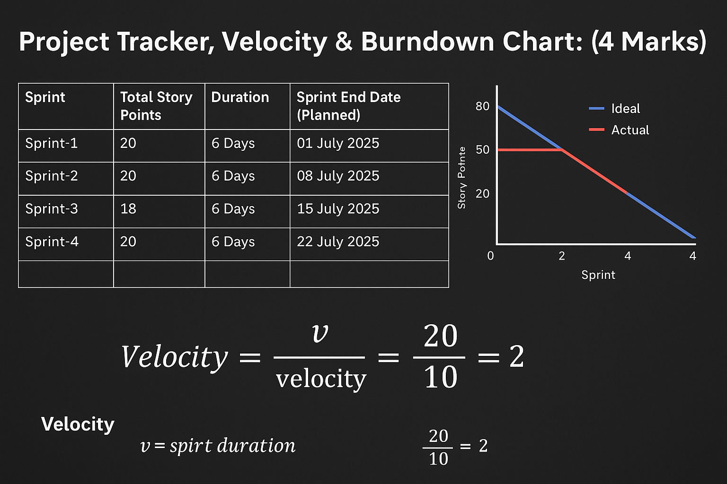

**Burndown Chart:**

A burn down chart is a graphical representation of work left to do versus time. It is often used in agile[software development](https://www.visual-paradigm.com/scrum/what-is-agile-software-development/) methodologies such as [Scrum](https://www.visual-paradigm.com/scrum/scrum-in-3-minutes/). However, burn down charts can be applied to any project containing measurable progress over time.

[**https://www.visual-paradigm.com/scrum/scrum-burndown-chart/**](https://www.visual-paradigm.com/scrum/scrum-burndown-chart/)

[**https://www.atlassian.com/agile/tutorials/burndown-charts**](https://www.atlassian.com/agile/tutorials/burndown-charts)

**Reference:**

[**https://www.atlassian.com/agile/project-management**](https://www.atlassian.com/agile/project-management)

[**https://www.atlassian.com/agile/tutorials/how-to-do-scrum-with-jira-software**](https://www.atlassian.com/agile/tutorials/how-to-do-scrum-with-jira-software)

[**https://www.atlassian.com/agile/tutorials/epics**](https://www.atlassian.com/agile/tutorials/epics)

[**https://www.atlassian.com/agile/tutorials/sprints**](https://www.atlassian.com/agile/tutorials/sprints)

[**https://www.atlassian.com/agile/project-management/estimation**](https://www.atlassian.com/agile/project-management/estimation)

[**https://www.atlassian.com/agile/tutorials/burndown-charts**](https://www.atlassian.com/agile/tutorials/burndown-charts)